

**Green University of Bangladesh**

**Department of Computer Science and Engineering (CSE)**

**Faculty of Sciences and Engineering**

**Semester: (Fall, Year: 2024), B.Sc. in CSE (Day)**

**Lab Report NO: 03**

**Course Title: Data Structure Lab**

**Course Code: CSE 206**

**Section: D8**

**Lab Experiment Name:** Implement of Bubble Sort, Insertion Sort, Selection Sort

**Student Details**

|  |  |  |
| --- | --- | --- |
| **Name** | | **ID** |
| **1.** | Ashab Uddin | 232002274 |

**Lab Date : 18/09/24**

**Submission Date : 24/09/24**

**Course Teacher’s Name : Md. Parvez Hossain**

|  |
| --- |
| **Lab Report Status**  **Marks: ………………………………… Signature: .....................**  **Comments: .............................................. Date: ..............................** |

**1. INTRODUCTION**

The purpose of this lab report is to understand the concepts of array sorting in C programming. We will explore how to sort arrays using different sorting techniques. This report focuses on implementing and comparing three types of sorting methods to solve practical problems efficiently through programming.

**2. OBJECTIVES**

* To gain knowledge of various sorting algorithms and their applications.
* To develop problem-solving skills through the implementation of sorting techniques in C.
* To enhance coding proficiency by applying sorting algorithms to practical problems in C.

**3. IMPLEMENTATION**

**Task 1:** Implement Bubble Sort algorithm using Arrays

**Solution:**

#include <stdio.h>

int main() {

    int A[100];

    int n, key;

    int swapped;

    printf("Enter the size of an array: ");

    scanf("%d", &n);

    printf("Enter the elements of the array:\n");

    for (int i = 0; i < n; i++) {

        scanf("%d", &A[i]);

    }

    for (int i = 0; i < n - 1; i++) {

        swapped = 0;

        for (int j = 0; j < n - i - 1; j++) {

            if (A[j] > A[j + 1]) {

                key = A[j];

                A[j] = A[j + 1];

                A[j + 1] = key;

                swapped = 1;

            }

        }

        if (!swapped) {

            break;

        }

    }

    printf("The Sorted array: \n");

    for (int i = 0; i < n; i++) {

        printf("%d ", A[i]);

    }

    printf("\n");

    return 0;

}

**Output:**

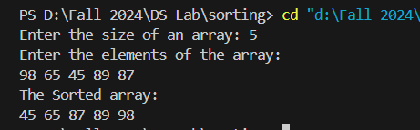

**Task 2**: Implement Insertion Sort algorithm using Arrays

**Solution:**

#include <stdio.h>

void insertionSort(int A[], int n) {

    for (int i = 1; i < n; i++) {

        int key = A[i];

        int j = i - 1;

        while (j >= 0 && A[j] > key) {

            A[j + 1] = A[j];

            j = j - 1;

        }

        A[j + 1] = key;

    }

}

int main() {

    int A[100], n;

    printf("Enter the size of the array: ");

    scanf("%d", &n);

    printf("Enter the elements of the array:\n");

    for (int i = 0; i < n; i++) {

        scanf("%d", &A[i]);

    }

    insertionSort(A, n);

    printf("The sorted array is:\n");

    for (int i = 0; i < n; i++) {

        printf("%d ", A[i]);

    }

    printf("\n");

    return 0;

}

**Output:**

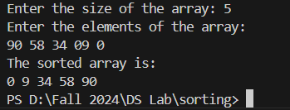

**Task 3:** Implement Selection Sort Algorithm Using Arrays.

**Solution:**

#include <stdio.h>

void selectionSort(int A[], int n) {

    for (int i = 0; i < n - 1; i++) {

        int minIndex = i;

        for (int j = i + 1; j < n; j++) {

            if (A[j] < A[minIndex]) {

                minIndex = j;

            }

        }

        if (minIndex != i) {

            int temp = A[i];

            A[i] = A[minIndex];

            A[minIndex] = temp;

        }

    }

}

int main() {

    int A[100], n;

    printf("Enter the size of the array: ");

    scanf("%d", &n);

    printf("Enter the elements of the array:\n");

    for (int i = 0; i < n; i++) {

        scanf("%d", &A[i]);

    }

    selectionSort(A, n);

    printf("The sorted array is:\n");

    for (int i = 0; i < n; i++) {

        printf("%d ", A[i]);

    }

    printf("\n");

    return 0;

}

**Output:**

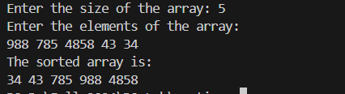

**4. DISCUSSION**

In this lab report, we explored three sorting algorithms. First, **Bubble Sort**, where adjacent elements are compared and swapped if needed, repeating this process until the array is sorted. Second, **Insertion Sort**, which places each element from the unsorted portion into its correct position in the sorted portion. Lastly, **Selection Sort** repeatedly scans the array to find the smallest element and moves it to the front, continuing until the entire array is sorted. Each algorithm offers a different approach to sorting, with varying efficiency based on the data set size.